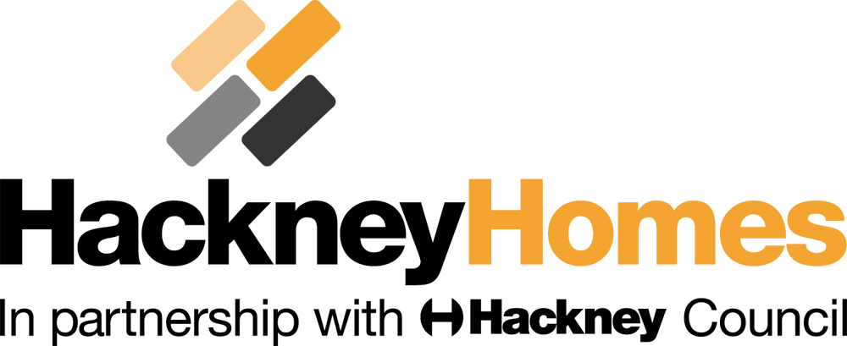 |  |  |  |  |  |  |  |  |  |  | Instruction to your  bank or building society  to pay by Direct Debit
Please fill in the whole form including official use box using a ball point pen and send it to: |  |  |  |  |  |  |  |  |  |  | Service user number
FREEPOST RENT ACCOUNTING  HACKNEY HOMES  CHRISTOPHER ADDISON HOUSE  LONDON  E8 1BJ |  |  |  |  |  |  |  |  |  |  | 9 | 7 | 2 | 3 | 2 | 8
FOR HACKNEY HOMES OFFICIAL USE ONLY
This is not part of the instruction to your bank or building society.
Please collect my monthly rent and an additional amount of £__________ (if applicable) each month to reduce my rent arrears.

Preferred date: 1st 

8th  16th  24th 

Name
Address
Phone

Name(s) of account holder(s)
Bank/building society account number

Branch sort code |  |  |  |  |  |  |  |  |  |  | Instruction to your bank or building society  Please pay London Borough of Hackney Direct Debits from the account detailed in this Instruction subject to the safeguards assured by the Direct Debit Guarantee. I understand that this Instruction may remain with Hackney Homes and, if so, details will be passed electronically to my bank/building society.
Name and full postal address of your bank or building society

To: The Manager |  |  |  |  | Bank/building society
Address |  |  |  |  |  |  |  |  |  |  | Signature(s)
 |  |  |  |  |  | Postcode |  |  |  |  | Date
Reference

Banks and building societies may not accept Direct Debit Instructions for some types of account

This guarantee should be detached and retained by the payer.


The Direct Debit Guarantee
- This Guarantee is offered by all banks and building societies that accept instructions to pay Direct Debits
- If there are any changes to the amount, date or frequency of your Direct Debit London Borough of Hackney will notify you 10 working days in advance of your account being debited or as otherwise agreed. If you request London Borough of Hackney to collect a payment, confirmation of the amount and date will be given to you at the time of the request.
- If an error is made in the payment of your Direct Debit, by London Borough of Hackney or your bank or building society, you are entitled to a full and immediate refund of the amount paid from your bank or building society
– If you receive a refund you are not entitled to, you must pay it back when London Borough of Hackney asks you to
- You can cancel a Direct Debit at any time by simply contacting your bank or building society. Written confirmation may be required. Please also notify us.

